What are the

**long-term spending patterns by Medicare beneficiaries**, and do **baseline patient factors that are potentially modifiable** predict these patterns?

Findings

In this cohort study using a **data-driven approach** to **classifying Medicare beneficiaries** by their **spending over 2 years**,

**5 patterns were identified** and could be predicted, including those with

1.**consistent spending levels** and others with

2. spending that increased progressively.

The **most influential potentially modifiable factors** were

**number of medications,**

**number of office visits, and**

**mean medication adherence**.

Meaning

These findings suggest that **spending by Medicare beneficiaries** falls into **5 distinct groups** and could be accurately predicted; this approach could be adapted by organizations to target interventions.

[Go to:](https://www.ncbi.nlm.nih.gov/pmc/articles/PMC7573679/)

Abstract

Importance

Current approaches to predicting health care costs generally rely on a **single composite value of spending** and focus on short time horizons. By contrast, examining patients’ spending patterns using dynamic measures applied over longer periods may better identify patients with different spending and **help target interventions to those with the greatest need.**

Objective

To **classify patients** by their **long-term, dynamic health care spending patterns** using a data-driven approach and assess the ability to predict spending patterns, particularly using **characteristics that are potentially modifiable** through intervention.

Design, Setting, and Participants

This cohort study used a **retrospective cohort design** from a random nationwide sample of Medicare fee-for-service administrative claims data to identify **beneficiaries aged 65 years or older** with continuous **eligibility from 2011 to 2013**. Statistical analysis was performed from August 2018 to December 2019.

Main Outcomes and Measures

**Group-based trajectory modeling** was applied to the claims data to classify the **Medicare beneficiaries by their total health care spending** **patterns** over a 2-year period.

The **ability to predict membership in each trajectory spending group** was assessed using **generalized boosted regression**, a data mining approach to model building and prediction, with split-sample validation. Models were estimated using (1**) prior-year predictors** and (2**) prior-year predictors potentially modifiable through intervention measured in the claims data.**

These models were evaluated using **validated C-statistics**. The relative influence of individual predictors in the models was evaluated.

Results

Among the 329 476 beneficiaries, **the mean (SD) age was 76.0 (7.2) years** and 190 346 (**57.8%)** were female.

This final 5-group model included a **minimal-user group** (group 1, 37 572 individuals [11.4%]), a **low-cost group** (group 2, 48 575 individuals [14.7%]), a **rising-cost group** (group 3, 24 736 individuals [7.5%]), a **moderate-cost group** (group 4, 83 338 individuals [25.3%]), and a **high-cost group** (group 5, 135 255 individuals [41.2%]).

Potentially modifiable characteristics strongly predicted these patterns (C-statistics range: 0.68-0.94).

For groups with **progressively increasing spending in particular**, the most influential factors were

number of medications (relative influence: 29.2),

number of office visits (relative influence: 30.3), and

mean medication adherence (relative influence: 33.6).

Conclusions and Relevance

Using a **data-driven approach, distinct spending patterns** were identified with high accuracy.

The **potentially modifiable predictors** of membership in the rising-cost group represent important levers for early interventions that may prevent later spending increases. This approach could be adapted by organizations to target quality improvement interventions, particularly because numerous health care organizations are increasingly using these routinely collected data.

Paper for case study?

With health care spending now **accounting for almost 18% of the US gross domestic product**, identifying individuals who may benefit from interventions to address potentially avoidable spending has become a central priority for health insurers and health care professionals.[1](https://www.ncbi.nlm.nih.gov/pmc/articles/PMC7573679/#zoi200700r1)

 Current approaches generally focus on prediction or intervention for patients who may have escalating costs on the basis of a single composite value of total spending over short time periods.[2](https://www.ncbi.nlm.nih.gov/pmc/articles/PMC7573679/#zoi200700r2),[3](https://www.ncbi.nlm.nih.gov/pmc/articles/PMC7573679/#zoi200700r3)

However, many patients experience **substantial increases or decreases in spending not captured by these approaches**.[4](https://www.ncbi.nlm.nih.gov/pmc/articles/PMC7573679/#zoi200700r4),[5](https://www.ncbi.nlm.nih.gov/pmc/articles/PMC7573679/#zoi200700r5),[6](https://www.ncbi.nlm.nih.gov/pmc/articles/PMC7573679/#zoi200700r6),[7](https://www.ncbi.nlm.nih.gov/pmc/articles/PMC7573679/#zoi200700r7),[8](https://www.ncbi.nlm.nih.gov/pmc/articles/PMC7573679/#zoi200700r8),[9](https://www.ncbi.nlm.nih.gov/pmc/articles/PMC7573679/#zoi200700r9) For example, Tamang et al[10](https://www.ncbi.nlm.nih.gov/pmc/articles/PMC7573679/#zoi200700r10) identified a definable group of low-spending patients in 1 year whose costs bloomed (ie, they became high-spending individuals) in the subsequent year in Denmark. Similarly, Lauffenburger et al[11](https://www.ncbi.nlm.nih.gov/pmc/articles/PMC7573679/#zoi200700r11) observed 7 distinct, dynamic patterns of spending over a 1-year period in commercially insured beneficiaries, including individuals whose costs increased rapidly toward the end of the year and another group of high-cost individuals for whom spending decreased.

These prior studies were conducted over a 1-year period, yet there may also be dynamic patterns of spending over longer periods that may have implications both for whom to outreach for intervention and when to do so.[1](https://www.ncbi.nlm.nih.gov/pmc/articles/PMC7573679/#zoi200700r1),[12](https://www.ncbi.nlm.nih.gov/pmc/articles/PMC7573679/#zoi200700r12)

 For example, patients with the same clinical conditions who are hospitalized early during a 12-month period may differ meaningfully from those hospitalized later, although both could be identified as having rising costs.[13](https://www.ncbi.nlm.nih.gov/pmc/articles/PMC7573679/#zoi200700r13),[14](https://www.ncbi.nlm.nih.gov/pmc/articles/PMC7573679/#zoi200700r14)

If these different spending patterns could be predicted using routinely collected data, then the ability to better proactively differentiate patients with increasing or decreasing spending patterns could better target interventions to those who are at greatest need of improved health or cost containment.[15](https://www.ncbi.nlm.nih.gov/pmc/articles/PMC7573679/#zoi200700r15) The predictive accuracy of spending may also be higher when evaluating a long-term, compared with a short-term, time horizon as seen for other outcomes.[16](https://www.ncbi.nlm.nih.gov/pmc/articles/PMC7573679/#zoi200700r16) **Accordingly, we sought to classify patients according to their spending patterns over a 2-year period and to evaluate the ability to predict these spending groups using patient characteristics that are potentially modifiable.**

Setting and Study Design

To be included, patients had to be aged 65 years or older and maintain continuous eligibility from January 1, 2011, to December 31, 2013. The cohort entry date was defined as January 1, 2012, to provide 1 year of prior year of baseline data (year 0) and 2 years of follow-up data (year 1 and year 2) (eFigure 1 in the [Supplement](https://www.ncbi.nlm.nih.gov/pmc/articles/PMC7573679/#note-ZOI200700-1-s)).

Costs

We measured ***total monthly health care spending over a 2-year period*** for each patient by summing the allowed amounts on all inpatient, outpatient, and prescription drug claims

. **Monthly costs were generated by summing the costs in each month** and **were standardized by dividing the summed costs by the number of days in that month** and **then multiplying the result by 30**.

100/31*30

Costs were then **logarithmically transformed** to normalize their distribution, after adding $0.01, as frequently done.[9](https://www.ncbi.nlm.nih.gov/pmc/articles/PMC7573679/#zoi200700r9),[18](https://www.ncbi.nlm.nih.gov/pmc/articles/PMC7573679/#zoi200700r18)

Costs **were inflated using** the Medical Care Component of the **Consumer Price Index to 2013 dollars** when necessary.

Predictors

Using data from **Medicare enrollment files and claims**, we defined

37 clinically relevant baseline characteristics

that were potential predictors of future spending (eTable 1 in the [Supplement](https://www.ncbi.nlm.nih.gov/pmc/articles/PMC7573679/#note-ZOI200700-1-s)). These **baseline variables were measured during the 12 months prior to the 2-year period during which cost outcomes were evaluated** (eFigure 1 in the [Supplement](https://www.ncbi.nlm.nih.gov/pmc/articles/PMC7573679/#note-ZOI200700-1-s)).

**Sociodemographic characteristics** included

age,

race/ethnicity

gender, and

community-level variables based on member’s zip code of residence,

median household income

educational attainment.

**Clinical comorbidities were measured** using *International Classification of Diseases, Ninth Revision* codes (eAppendix and eTable 1 in the [Supplement](https://www.ncbi.nlm.nih.gov/pmc/articles/PMC7573679/#note-ZOI200700-1-s)). Each patients’

number of unique prescriptions by generic name (ie, therapeutic complexity)

physician office visits,

emergency department visits,

hospitalizations,

unique physicians visited,

unique pharmacies used,

benefits’ generosity[19](https://www.ncbi.nlm.nih.gov/pmc/articles/PMC7573679/#zoi200700r19) (copayments and deductibles or total net payments), and

baseline year total costs were also measured.

Adherence to long-term medication classes (eg, β-blockers) was measured in the baseline year.[11](https://www.ncbi.nlm.nih.gov/pmc/articles/PMC7573679/#zoi200700r11)

For each class, we created a supply diary beginning with the first fill for each class in the baseline year. This diary linked all observed fills based on dispensing date and days’ supply; switching was allowed within each class (eg, β-blockers). From this, we calculated the proportion of days covered (PDC) as a mean across classes that the patient filled to yield 1 mean PDC.[20](https://www.ncbi.nlm.nih.gov/pmc/articles/PMC7573679/#zoi200700r20),[21](https://www.ncbi.nlm.nih.gov/pmc/articles/PMC7573679/#zoi200700r21)

We **categorized each predictor by whether it was potentially modifiable,** defined by whether it could theoretically be addressed in interventions and by classifications in prior literature.[22](https://www.ncbi.nlm.nih.gov/pmc/articles/PMC7573679/#zoi200700r22),[23](https://www.ncbi.nlm.nih.gov/pmc/articles/PMC7573679/#zoi200700r23) For example, **number of unique physicians could be potentially modifiable**, while **race/ethnicity is not**. In total,

**we classified 10 predictors as potentially modifiable** ([Table 1](https://www.ncbi.nlm.nih.gov/pmc/articles/PMC7573679/table/zoi200700t1/)).

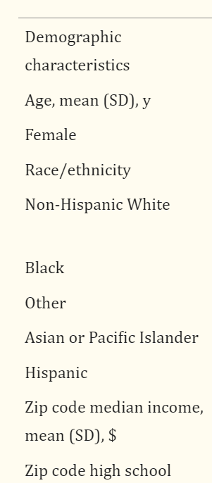

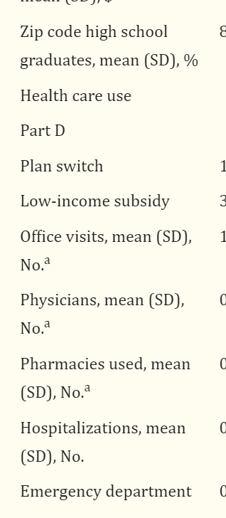

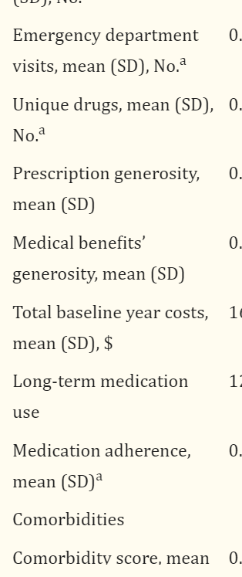

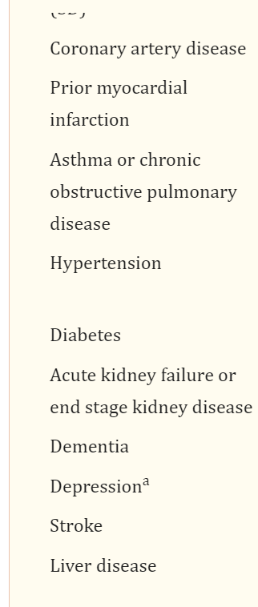

Data-Driven Approach to Modeling Long-term Costs

We used **trajectory modeling** to empirically **classify spending during follow-up**.

One advantage is that it allows the **data to define the cost outcomes**, rather than using arbitrarily selected thresholds.[24](https://www.ncbi.nlm.nih.gov/pmc/articles/PMC7573679/#zoi200700r24)

It also **considers changes in spending over time**, **rather than aggregating costs over a set time.**[25](https://www.ncbi.nlm.nih.gov/pmc/articles/PMC7573679/#zoi200700r25)

 To **define spending patterns, we used the previously described SAS** procedure Proc Traj, a free add-on.[24](https://www.ncbi.nlm.nih.gov/pmc/articles/PMC7573679/#zoi200700r24),[25](https://www.ncbi.nlm.nih.gov/pmc/articles/PMC7573679/#zoi200700r25),[26](https://www.ncbi.nlm.nih.gov/pmc/articles/PMC7573679/#zoi200700r26)

 In brief, group-based trajectory models are an **application of finite mixture modeling** that **identify clusters of individuals** with similar **outcome patterns over time**.[24](https://www.ncbi.nlm.nih.gov/pmc/articles/PMC7573679/#zoi200700r24)

**This modeling approach analyzes longitudinal data** by fitting a semiparametric (discrete) mixture model, **estimating each individual’s probability of membership in each group**, and

**assigning them to the group according to their highest probability**.

We **modeled longitudinal cost trajectories** using calendar month as the **time variable, costs in each month**, **order equal to 4**, and a **censored-normal distribution** (linear between minimum and maximum values).[11](https://www.ncbi.nlm.nih.gov/pmc/articles/PMC7573679/#zoi200700r11),[24](https://www.ncbi.nlm.nih.gov/pmc/articles/PMC7573679/#zoi200700r24),[26](https://www.ncbi.nlm.nih.gov/pmc/articles/PMC7573679/#zoi200700r26)

**The models were estimated using a forward classifying approach** using **2 to 7 groups,** each time investigating **model fit using the bayesian information criterion (BIC)( selection among a finite set of models),** whereby a

**lower BIC indicates better model fit.**[24](https://www.ncbi.nlm.nih.gov/pmc/articles/PMC7573679/#zoi200700r24)

The number of groups investigated was capped at 7 on the basis of groupings observed in prior work.[11](https://www.ncbi.nlm.nih.gov/pmc/articles/PMC7573679/#zoi200700r11) In addition to considering BIC, other key considerations in selecting the **best-fitting trajectory were the ability to visually interpret separate groups**,

**minimum membership probabilities in each group**, and having 5% or more of the sample in each group.[26](https://www.ncbi.nlm.nih.gov/pmc/articles/PMC7573679/#zoi200700r26),[27](https://www.ncbi.nlm.nih.gov/pmc/articles/PMC7573679/#zoi200700r27),[28](https://www.ncbi.nlm.nih.gov/pmc/articles/PMC7573679/#zoi200700r28)

Statistical Analysis

After selecting the best **fitting number of trajectories**,

we **assessed the ability to predict membership** in each 2-year trajectory group using **boosted logistic regression**, a nonparametric machine learning method.

The boosted algorithm is considered **one of the best data-mining approaches for prediction problems**.[16](https://www.ncbi.nlm.nih.gov/pmc/articles/PMC7573679/#zoi200700r16),[29](https://www.ncbi.nlm.nih.gov/pmc/articles/PMC7573679/#zoi200700r29)

 Specifically, the algorithm creates a **prediction model by building numerous small regression trees** that together provide highly **accurate classification**.[30](https://www.ncbi.nlm.nih.gov/pmc/articles/PMC7573679/#zoi200700r30)

The boosting algorithm has **several built-in protections** from model overfitting, **provides automatic variable selection**, and describes the **relative influence of predictors**.[31](https://www.ncbi.nlm.nih.gov/pmc/articles/PMC7573679/#zoi200700r31)

They also consider all possible interaction terms between potential predictors.

We used the gbm package in R with **5-fold cross-validation** to identify the **optimal number of trees** and applied standard default values for tuning parameters to identify the optimal model.[16](https://www.ncbi.nlm.nih.gov/pmc/articles/PMC7573679/#zoi200700r16)

For each trajectory group, we estimated 2 separate models.

The **first included all 37 baseline predictors** (model 1) and the **second included only the 10 baseline predictors** that were considered a priori to be potentially modifiable (model 2). Because of the ability of **boosted regression to handle missing data**, an indicator of

long-term medication use and

mean PDC were both included as variables for model

1,

and mean PDC was included alone as a variable for model 2.

To avoid **overoptimism bias,** we used **internal split-sample validation** by randomly dividing the **full cohort into 2 halves** as an initial derivation sample and a validation sample for all models.[32](https://www.ncbi.nlm.nih.gov/pmc/articles/PMC7573679/#zoi200700r32) We evaluated each model through discrimination measures.[33](https://www.ncbi.nlm.nih.gov/pmc/articles/PMC7573679/#zoi200700r33) Discrimination, the model’s ability to distinguish between patients who do and do not experience the outcome, was measured by the C-statistic, which ranges **from 0.5 (noninformative model) to 1.0 (perfect prediction).**[**34**](https://www.ncbi.nlm.nih.gov/pmc/articles/PMC7573679/#zoi200700r34)**,**[**35**](https://www.ncbi.nlm.nih.gov/pmc/articles/PMC7573679/#zoi200700r35)

For clinical context, we explored the association between **potentially modifiable baseline characteristics and membership in a rising-cost trajectory compared** with **other trajectory groups** that had similar spending at baseline. Specifically, we used

**multivariable logistic regression to compare membership** in the **rising-cost trajectory**, including each potentially modifiable variable vs other groups.

This approach provides insight into baseline factors that may help **distinguish patients who become costly later** (ie, at least a year later) and potential levers for interventions. We also explored the relative influence of each **potentially modifiable predictor** from model 2.

We also evaluated the **ability to predict patients who experience rising costs in year 2 defined using a decile-threshold approach**

(ie, those in the **lower 90% of spending in year 1** and then were in the top **10% of spending in year 210**) and

patients who in trajectory modeling were estimated as belonging to a **rising-cost trajectory.** For this approach,

we estimated each outcome with **2 additional models with boosted regression.**

Model 3 used all baseline predictors, and model 4 used the potentially modifiable predictors.

This **approach helps provide insight into whether these spending increases could be accurately predicted u**sing baseline information less temporal to the spending changes, which could ultimately inform intervention design and allow more time for them to be implemented.

We conducted several sensitivity analyses. Although our primary analysis included zip code sociodemographic characteristics, we also included patients’ region of residence based on enrollment files as a predictor in model 1. Then, we included adherence to each class separately as predictors in models 1 and 2. Finally, we repeated measurements and analyses in a subsequent year (ie, 2012-2014) to confirm generalizability (eAppendix in the [Supplement](https://www.ncbi.nlm.nih.gov/pmc/articles/PMC7573679/#note-ZOI200700-1-s)).

All analyses except for the boosted regression were performed using SAS version 9.4 (SAS Institute); the boosting algorithm was performed using R version 3.4.1 (The R Project for Statistical Computing). Statistical analysis was performed from August 2018 to December 2019

Study Population and Characteristics

Our cohort consisted of 329 476 patients (eTable 2 in the [Supplement](https://www.ncbi.nlm.nih.gov/pmc/articles/PMC7573679/#note-ZOI200700-1-s)). Their mean (SD) age **was 76.0** (7.2) years, and 190 346 (57.8%) were women.

A 5-group trajectory model best described the 2-year spending patterns ([Figure](https://www.ncbi.nlm.nih.gov/pmc/articles/PMC7573679/figure/zoi200700f1/)); the model on the log scale is shown in eFigure 2 in the [Supplement](https://www.ncbi.nlm.nih.gov/pmc/articles/PMC7573679/#note-ZOI200700-1-s). The probabilities of group membership are in eTable 3 in the [Supplement](https://www.ncbi.nlm.nih.gov/pmc/articles/PMC7573679/#note-ZOI200700-1-s). Trajectories with alternative numbers of groups and corresponding BICs are shown in eFigure 3 in the [Supplement](https://www.ncbi.nlm.nih.gov/pmc/articles/PMC7573679/#note-ZOI200700-1-s); models with more groups had marginal improvements and were less interpretable.

[[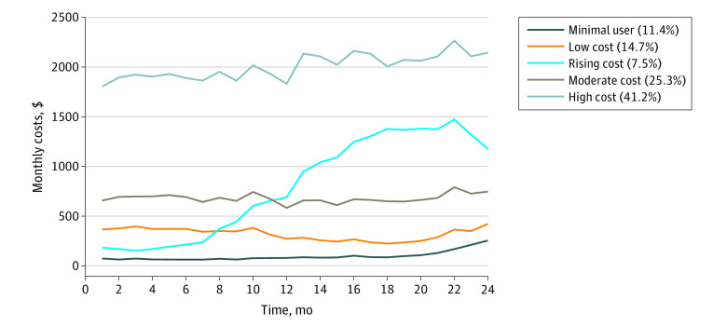](https://www.ncbi.nlm.nih.gov/core/lw/2.0/html/tileshop_pmc/tileshop_pmc_inline.html?title=Click%20on%20image%20to%20zoom&p=PMC3&id=7573679_jamanetwopen-e2020291-g001.jpg)](https://www.ncbi.nlm.nih.gov/core/lw/2.0/html/tileshop_pmc/tileshop_pmc_inline.html?title=Click%20on%20image%20to%20zoom&p=PMC3&id=7573679_jamanetwopen-e2020291-g001.jpg" \t "tileshopwindow)

[Figure.](https://www.ncbi.nlm.nih.gov/pmc/articles/PMC7573679/figure/zoi200700f1/)

**2-Year Spending Patterns Using Trajectory Modeling**

The mean observed spending levels using 5-group trajectory modeling in the full sample are plotted. The percentages in the key refer to the number of patients who belong to each trajectory group out of the full cohort (bayesian information criterion for this model: 21704747).

This final 5-group model included a minimal-user group (group 1, 37 572 individuals [11.4%]), a low-cost group (group 2, 48 575 individuals [14.7%]), a rising-cost group (group 3, 24 736 individuals [7.5%]), a moderate-cost group (group 4, 83 338 individuals [25.3%]), and a high-cost group (group 5, 135 255 individuals [41.2%]). Baseline characteristics for each group are shown in [Table 1](https://www.ncbi.nlm.nih.gov/pmc/articles/PMC7573679/table/zoi200700t1/).

Cost Prediction

[Table 2](https://www.ncbi.nlm.nih.gov/pmc/articles/PMC7573679/table/zoi200700t2/) shows the results of the main prediction models in the validation sample. Four of the 5 2-year spending trajectory groups could be accurately predicted using all baseline predictors, especially the minimal-user (C-statistic: 0.951), low-cost (C-statistic: 0.810), rising-cost (C-statistic: 0.764), and high-cost groups (C-statistic: 0.899). Using potentially modifiable predictors alone, overall predictive ability remained moderate to strong, with the exception of the moderate-cost group (eg, C-statistic: 0.684).

Table 2.

**Ability of Models to Predict 2-Year Spending Trajectory Groups**

| **Group** | **Validation C-statistic** |
| --- | --- |
| All baseline predictors, model 1 |  |
| Group 1: minimal user | 0.951 |
| Group 2: low cost | 0.810 |
| Group 3: rising cost | 0.764 |
| Group 4: moderate cost | 0.728 |
| Group 5: high cost | 0.899 |
| Potentially modifiable predictors, model 2 |  |
| Group 1: minimal user | 0.942 |
| Group 2: low cost | 0.783 |
| Group 3: rising cost | 0.753 |
| Group 4: moderate cost | 0.684 |
| Group 5: high cost | 0.873 |

[Open in a separate window](https://www.ncbi.nlm.nih.gov/pmc/articles/PMC7573679/table/zoi200700t2/?report=objectonly)

[Table 3](https://www.ncbi.nlm.nih.gov/pmc/articles/PMC7573679/table/zoi200700t3/) shows potentially modifiable prior-year predictors of being in a rising-cost trajectory compared with the other 3 groups with similar spending in the prior baseline year (mean, $1500-$8000 in year 0). In particular, using more medications (odds ratio [OR]: 0.81; 95% CI, 0.79-0.84) and having more office visits (OR: 0.98; 95% CI, 0.97-0.99) were associated with lower odds of being in the rising-cost trajectory. Seeing more physicians (OR: 1.04; 95% CI, 1.02-1.06) and using tobacco (OR: 1.10; 95% CI, 1.02-1.20) were also factors independently associated with rising-cost membership. eFigure 4 in the [Supplement](https://www.ncbi.nlm.nih.gov/pmc/articles/PMC7573679/#note-ZOI200700-1-s) shows the relative influence plots for each group incorporating only potentially modifiable characteristics (model 2). The plot for predicting the rising-cost group in particular indicates that the most predictive potentially modifiable factors were mean medication adherence (relative influence: 33.6), number of office visits (relative influence: 30.3), and number of medications (relative influence: 29.2).

**Association Between Potentially Modifiable Factors and Membership in the Rising-Cost Spending Trajectory (Group 3) vs Other Trajectory Groupsa**

| **Characteristics** | **OR (95% CI) for group 3: rising cost** |
| --- | --- |
| Intercept (SE) | −1.86 (0.02) |
| Baseline covariate |  |
| Unique medications, No.b | 0.81 (0.79-0.84) |
| Office visits, No.b | 0.98 (0.97-0.99) |
| Physicians, No.b | 1.04 (1.02-1.06) |
| Pharmacies, No.b | 0.99 (0.95-1.02) |
| Emergency department visits, No.b | 0.98 (0.94-1.01) |
| Depression | 1.01 (0.92-1.10) |
| Tobacco use | 1.10 (1.02-1.20) |
| Obesity | 1.08 (0.98-1.19) |
| Acute stress | 0.87 (0.74-1.02) |

[Open in a separate window](https://www.ncbi.nlm.nih.gov/pmc/articles/PMC7573679/table/zoi200700t3/?report=objectonly)

Abbreviation: OR, odds ratio.

aConducted within validation sample using logistic regression model with only potentially modifiable covariates compared with groups 1, 2, and 4.

bOdds ratios are presented as a 1-unit increase for continuous variables.

The results from the models predicting **rising costs using a decile-threshold–based method** and the trajectory group method are shown in eTable 4 in the [Supplement](https://www.ncbi.nlm.nih.gov/pmc/articles/PMC7573679/#note-ZOI200700-1-s). Patients in the decile-threshold–based approach had higher total 2-year costs on average ($39 737), compared with the trajectory approach ($23 670). The ability to predict decile-threshold–based rising costs (model 4 C-statistic: 0.643) was lower than the trajectory-based approach (model 4 C-statistic: 0.753).

Sensitivity analyses incorporating region of residence and medication adherence to by class are shown in eTables 5 and 6 in the [Supplement](https://www.ncbi.nlm.nih.gov/pmc/articles/PMC7573679/#note-ZOI200700-1-s). Notably, trajectory group membership was fairly similar across regions, and including these predictors did not meaningfully change C-statistics. Replication in a subsequent year of data resulted in similar patterns and sizes of group membership (eFigure 5 in the [Supplement](https://www.ncbi.nlm.nih.gov/pmc/articles/PMC7573679/#note-ZOI200700-1-s)) as well as ability to predict those groups (eTable 7 in the [Supplement](https://www.ncbi.nlm.nih.gov/pmc/articles/PMC7573679/#note-ZOI200700-1-s)).

[Go to:](https://www.ncbi.nlm.nih.gov/pmc/articles/PMC7573679/)

Discussion

Using a data-driven approach to classify 2-year health spending for Medicare beneficiaries, we observed **5 distinct spending patterns. Membership in these groups could be accurately predicted**, even when using a simple set of potentially modifiable characteristics from claims data. These results suggest that this approach could potentially help inform the design, application, and timing of interventions.

Prior efforts to predict health care spending have generally focused on a single composite value, such as total yearly costs or a threshold-based measure, such as being in the top 5% of spending, both of which collapse an entire year’s spending into a static variable. These approaches have had modest accuracy; C-statistics for threshold-based outcomes have generally ranged from 0.6 to 0.8.[2](https://www.ncbi.nlm.nih.gov/pmc/articles/PMC7573679/#zoi200700r2),[5](https://www.ncbi.nlm.nih.gov/pmc/articles/PMC7573679/#zoi200700r5),[36](https://www.ncbi.nlm.nih.gov/pmc/articles/PMC7573679/#zoi200700r36),[37](https://www.ncbi.nlm.nih.gov/pmc/articles/PMC7573679/#zoi200700r37) Two recently published approaches offer other cluster-based solutions to elucidate subgroups of high-cost patients with some notable successes.[38](https://www.ncbi.nlm.nih.gov/pmc/articles/PMC7573679/#zoi200700r38),[39](https://www.ncbi.nlm.nih.gov/pmc/articles/PMC7573679/#zoi200700r39) However, these were not applied to evaluate changes in spending, outcomes over more than 1 year, or to elucidate patients with rising costs.[38](https://www.ncbi.nlm.nih.gov/pmc/articles/PMC7573679/#zoi200700r38),[39](https://www.ncbi.nlm.nih.gov/pmc/articles/PMC7573679/#zoi200700r39) They also focused on Medicare Advantage populations, which can differ from fee-for-service beneficiaries.[40](https://www.ncbi.nlm.nih.gov/pmc/articles/PMC7573679/#zoi200700r40),[41](https://www.ncbi.nlm.nih.gov/pmc/articles/PMC7573679/#zoi200700r41)

Patients may have **dynamic patterns of spending over longer periods of time** that can be potentially meaningful, with implications on whom to outreach for intervention as well as when and perhaps how to do so.[1](https://www.ncbi.nlm.nih.gov/pmc/articles/PMC7573679/#zoi200700r1),[12](https://www.ncbi.nlm.nih.gov/pmc/articles/PMC7573679/#zoi200700r12) For example, Tamang et al[10](https://www.ncbi.nlm.nih.gov/pmc/articles/PMC7573679/#zoi200700r10) identified low-spending patients in 1 year whose costs bloomed in the subsequent year using thresholds. When applied to our data, the ability to predict these patients using baseline data alone was modest. Using a data-driven approach, we observed a **similarly sized group whose costs later increased that could be predicted somewhat better.** One possible explanation could be that the 2-year time horizon itself as an outcome helped discriminate between groups.

The ability to proactively differentiate between patients with rising or falling spending patterns using distally measured variables could better target interventions to those who are at greatest need. If successful, using these longer time horizons could allow more time for the implementation of potential interventions.[42](https://www.ncbi.nlm.nih.gov/pmc/articles/PMC7573679/#zoi200700r42)

Focusing interventions on patients with rising costs has some theoretical advantages, even though predictive ability was modest. First, the size of the group identified in this study was modest (ie, 7.5%). Of course, it still may be infeasible to intervene upon a group this large, and not all costs may be preventable. Identifying additional segmentation may be necessary, and the use of this approach may be just a starting point. Regardless, the ability to predict better could target interventions to those at greater need, and targeting has been shown to result in better population-level outcomes.[43](https://www.ncbi.nlm.nih.gov/pmc/articles/PMC7573679/#zoi200700r43)

When considering potential interventions, a prediction rule comprising the most influential potentially modifiable variables could be applied to better target patients. We observed several clinically actionable characteristics, such as therapeutic complexity (**ie, number of medications or office visits), depression, medication adherence, and tobacco** use that could be levers for interventions. Filling fewer medications and having fewer office visits were also predictors of the rising-cost trajectory, suggesting that patients may not be getting sufficient care to prevent future escalation of health problems.[22](https://www.ncbi.nlm.nih.gov/pmc/articles/PMC7573679/#zoi200700r22) This information could also be used for intervention design to improve care.

Many health care organizations, insurers, researchers, and policy makers use claims data to identify patients for interventions. Therefore, the ability to better leverage these routinely collected data for cost predictions and interventions with a variety of more nuanced cost-modeling methods holds wide potential. Moreover, using data-driven approaches to classify longer-term spending may hold promise compared with threshold-based approaches alone.

Limitations

Several limitations warrant mention. First, we examined trajectories from January to December; patients with incomplete enrollment or other policy start and end dates may differ. Because of differences in how outcomes are categorized, model performance of predicting a cost trajectory (binary outcome) cannot be directly compared with predicting total costs (continuous outcome) or patients defined by the rising-cost decile-threshold approach. The variables included in prediction models may also not be exhaustive, and although we used validated algorithms, they may be insufficiently sensitive. Trajectory modeling also provides predicted group membership; individual members may be assigned to their closest trajectory, but there could be within-group heterogeneity. The high-cost group was large, possibly because of how the model was specified (ie, log costs); one could potentially apply trajectories to identify subgroups within that group for further segmentation. Although group distribution did not differ on the basis of geographical region, the costs themselves were not adjusted for region; similarly, moving could have impacted relative changes in spending, but this was beyond the scope of this study. Furthermore, these results may not be generalizable to other payment systems, such as non–fee-for-service Medicare, Medicaid, or commercially insured beneficiaries. Although these other beneficiaries may have different spending levels, prior work has suggested similar patterns.[11](https://www.ncbi.nlm.nih.gov/pmc/articles/PMC7573679/#zoi200700r11) Regardless, the same groups or predictive ability may not apply to other types of beneficiaries, and the results should be studied further to confirm reproducibility.

[Go to:](https://www.ncbi.nlm.nih.gov/pmc/articles/PMC7573679/)

Conclusions

Using trajectory modeling to examine a 2-year time horizon improved the understanding of dynamic patterns, including the identification of a group of patients with progressively increasing costs and a group of patients with consistently high spending. This approach could be potentially adapted by health care organizations to improve cost-containment efforts.